1. Complete the table with the correct number protons, electrons, and neutrons.
 | Protons | Electrons | Neutrons
(a) 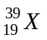
(b) 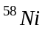
(c) 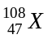
(d) 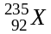
 |  |  |  | /6

2. Complete the following for neutral atoms
Symbol | 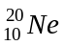
Mass number |  | 19 | 10
Atomic number
Number of protons
Number of neutrons
Number of electrons |  |  | 5
 |  |  | /7

3. Fill in the following table for charged atoms
Symbol  (include charge) |  | Mg²⁺
Mass number | 33 | 24
Atomic number |  |  | 19
Number of protons | 16 | 12
Number of neutrons
Number of electrons | 18 |  | 18
 |  |  | /5

4. To better understand the structure of the atom, Rutherford conducted an experiment. A schematic of the apparatus is shown below,

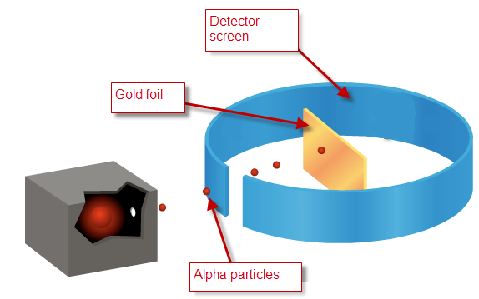

(a) For each of the atomic models below, predict the outcome that Rutherford would have observed if the atoms that made up the gold foil looked as shown. In other words explain the path that the alpha particles would have taken.
Plum Pudding Model  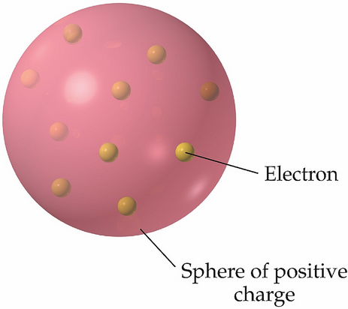 | Outcome
Billiard ball  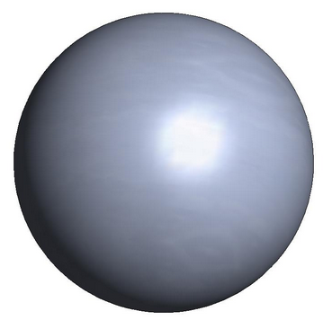 | Outcome
(b) Describe what Rutherford actually observed.

(c) Draw a rough sketch of an atom that reflects the model Rutherford was able to conclude from his experiment. Your drawing should indicate the location of the protons, neutrons, and electrons.

 |  | /6

